**Parish Mass Intentions**

**SATURDAY, JUNE 10th, 2023**

5:00 PM   For the People of the Parish

**SUNDAY,** **JUNE 11th, 2023**

7:30 AM     LOWER CHURCH – MESSE CRÉOLE

Repos de l’âme de Luc Estimé et de

Marie Gracieuse Zephyr – par leurs enfants

10:00 AM   UPPER CHURCH– ENGLISH MASS

     For the People of the Parish

11:00 AM   LOWER CHURCH – MISA ESPANOL

For the People of the Parish

1:00 PM      UPPER CHURCH – MESSE CRÉOLE

Remerciement a Dieu, Anniversaire de

naissance de Marlaine Augustin

- par Marlaine Augustin 

**MONDAY, JUNE 12th, 2023**

  7:30 AM    No Mass Intentions

9:00 AM   Repos de l’âme de Monee Catulle

–par sa famille

**TUESDAY, JUNE 13th, 2023**

7:30 AM   No Mass Intentions

9:00 AM  No Mass Intentions

**WEDNESDAY, JUNE 14th, 2023**

7:30 AM    No Mass Intentions

9:00 AM   No Mass Intentions

**THURSDAY, JUNE 15th, 2023**

7:30 AM    No Mass Intentions

9:00 AM   No Mass Intentions

**FRIDAY, JUNE 16th, 2023**

7:30 AM    No Mass Intentions

7:30 AM    No Mass Intentions

**SATURDAY, JUNE 17th, 2023**

8:00 AM   No Mass Intentions

9:00 AM   No Mass Intentions

**Bread and Wine Offering**

The bread and wine, this week are being offered for the special intentions of Marlaine Augustin.

**Sanctuary Lamp Offering**

The sanctuary lamp, this week is being offered in loving memory of Marie Helene Paul by her daughter, Marlaine Augustin.

__________________________________________

***PLEASE PRAY FOR THE SICK ESPECIALLY***

Yvrose Auguste, Giselle Beausoleil, Georgette Charles, Kenneth Culajay, Amina Joseph, Andre Innocent, Bob Johnson, Fleurisca Lexius, George Farid Puzo, Candy Primus, Herma Farrell, Denesse Reddi-Fraser

Elisa Quashie Lawrence, Agatha Bristow______________

***PLEASE PRAY FOR ALL WHO HAVE RECENTLY DEPARTED ESPECIALLY*:**

Monee Catulle, Marlaine Charles

____________________________________

MOST HOLY BODY AND

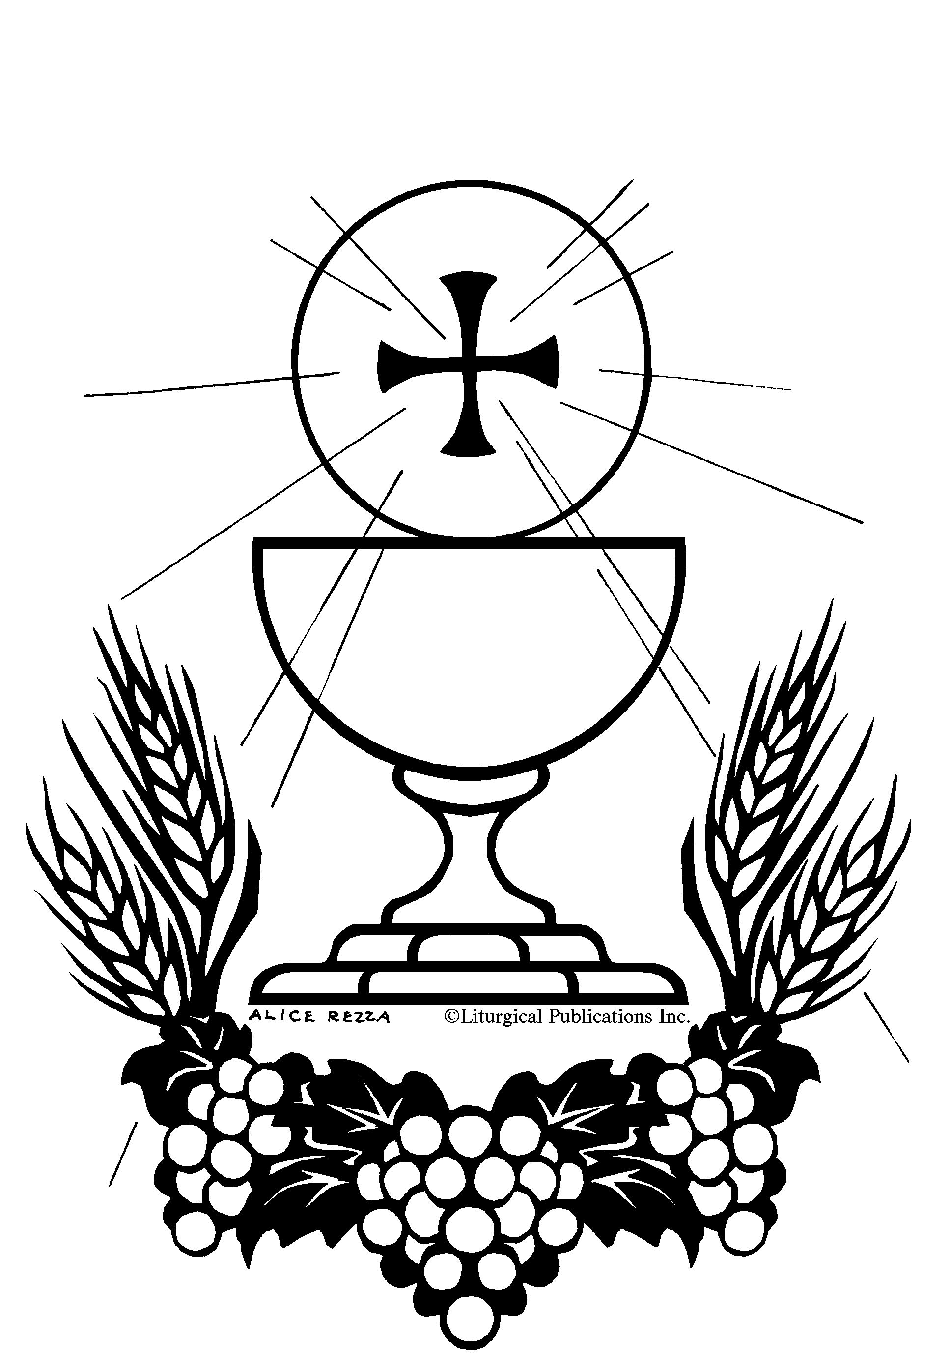

BLOOD OF CHRIST

My Brothers and Sisters in Christ,

    Today we celebrate our belief that under the appearance of bread and wine, we see, eat, and drink the real presence of Christ as true food and true drink. We adore the Body and Blood of Christ with processions, exposition of the Blessed Sacrament, and Benediction as extensions of what we celebrate in the Eucharist. There we take bread and wine, bless and thank God for them, break the bread and share the cup, to eat and drink the Body and Blood of Christ they have become. But we don’t stop there. We are sent into the world to be Christ’s body broken in service and his blood poured out in love for our sisters and brothers. We become what we eat and drink, as St. Augustine commanded: “Be who you are, the Body of Christ.” And then we live what we have become.

    Our celebration of the Eucharist and of this solemnity calls us to be for our world what God was for our ancestors in the desert: a guide through the deserts of human lives, water of life for places that are parched and dry, and the loving food of hope, healing, mercy and light that Jesus was in his day and time. Become what we eat, the Body of Christ. Become what we drink, the Blood of Christ. Celebrate the Eucharist and befriend one another with Jesus’ love that refreshes, offers eternal goodness, and satisfies the hungry heart. Eat. Drink. Become the light and food that dispel the gloom of night.

    Generous God, how holy is the feast, when Christ becomes our food. By eating and drinking the Body and Blood of Christ and knowing Christ present in the Eucharist, help me to feed the whole world with your loving and merciful presence today.

_________________________________________

**Vocation**

“Jesus has given us His Body to eat and His Blood to drink so as to nourish us on our journey towards Heaven. All are called in Christ, but some are chosen to nourish His body as priests and in the consecrated life. Could you be among them? Contact the Vocation Office at

718-827-2454 or email: vocations@diobrook.org __________________________________________

**YOUR** **WEEKLY GIFT TO GOD\***

****Sunday, June 04th:**

**Regular Contributions** $ 7,130

**Online Offerings not reported**

**Weekly budget** -10,525

**Difference -3,395**

\***Give to God with love by placing your gift inside the offering envelopes. May God continue to bless you.**

***Annual Catholic Appeal 2023***

The 2023 Annual Catholic Appeal is underway. Our goal this year is $44,000.00 We will ask everyone to consider making a gift to the 2023 Annual Catholic Appeal at all of our Masses. You can also make a pledge today by texting ACA to 917-336-1255. Your donation supports the many needs of our Diocese.

If 150 Parishioners pledge $300 each to the 2023 Annual Catholic Appeal, we will exceed our goal.

**St. Jerome Pilgrimage to**

**Egypt, The Holy Land and Jordan**

**May 1, 2024 to May 15, 2024**

Join your fellow parishioners in an unforgettable pilgrimage trip to Egypt, The Holy Land and Jordan under the spiritual direction of our pastor, Reverend Jean Yvon Pierre.

**$4,899 from New York**

**Single Room Supplement- $899**

Your tour includes: Roundtrip air flight from New York, Airline Taxes and fuel surcharges, accommodation in four star hotels, daily breakfast and dinner, sightseeing in a private air conditioned motor coach, assistance of a tour guide, entrance fees and local taxes, daily mass where possible and visa for Egypt and border crossing fees. Pick up a flyer in the church for more information. For reservations, call Yanick Thomas at (347) 683-3869 or Arlene Roopchand at (917)6470355 or the Rectory Office at (718)462-0223. You may conveniently register online @ www.AdriaticPilgrimages.com

YH24, 050124, T 61555

Tour Date Code ID#______

**FAITH FORMATION REGISTRATION**

Registration for Religious Education is ongoing. Please contact the Faith Formation Office at 646-664-6738 or via email: stjeromeff@outlook.com to make an appointment to register. You can also register online at: [www.givecentral.org/stjb-ff](http://www.givecentral.org/stjb-ff)

**INTERNATIONAL CUISINE DAY**

Members of the Parish Fundraising Committee cordially invite you to an international Cuisine Day on Saturday, June 17th, 2023 from 12:00 pm. in the School Gymnasium. The price is $40 for adults and $20 for children. This event is for all ages. Come and experience another culture through delicious food and music.

**The Corpus Christi Procession**

**June 11th, 2023**

This is the route for the Corpus Christi Procession:

1. Procession leaves St. Jerome and head southbound on Nostrand to Farragut Rd. Make a right, the first depository is at 2803 Farragut Rd.
2. Leave Farragut and head North on East 29th Street. The second station is at the Convent.
3. Continue north on 29th street to Clarendon Rd turn right to New York Ave.
4. Make a right on New York, third station is at 1237 New York Ave. Continue on New York to Ave D, make a right and then a left on Nostrand back to the church

**The Pope's Monthly Intentions for 2023**

***JUNE*: For the Abolition of Torture**

We pray that the international community may commit in a concrete way to ensuring the abolition of torture and guarantee support to victims and their families.

___________________________________________

**MASS INTENTIONS & BREAD AND WINE OFFERINGS**

A Mass intention or Bread and Wine offerings can be requested for a loved one (living or deceased), or for a friend, or in thanksgiving to God for favors granted etc.

**Readings for the Week –June 11th, 2023**

**Monday**: 2 Cor 1:1-7; Ps 34:2-3, 4-5, 6-7, 8-9; Mt 5:1-12  
**Tuesday**: 2 Cor 1:18-22; Ps 119:129, 130, 131, 132, 133, 135; Mt 5:13-16  
Wednesday: 2 Cor 3:4-11; Ps 99:5, 6, 7, 8, 9; Mt 5:17-19  
Thursday: 2 Cor 3:15 — 4:1, 3-6; Ps 85:9ab, 10, 11-12, 13-14; Mt 5:20-26  
Friday: Dt 7:6-11; Ps 103:1-2, 3-4, 6-7, 8, 10; 1 Jn 4:7-16; Mt 11:25-30  
Saturday: 2 Cor 5:14-21; Ps 103:1-2, 3-4, 9-10, 11-12; Lk 2:41-51  
Sunday: Ex 19:2-6a; Ps 100:1-2, 3, 5; Rom 5:6-11; Mt 9:36—10:8

__________________________________________

